Used Commands:-
1: pwd: present working directory.
2: cd: change directory location.
3: mkdir: create directory.
4: ls: list of files available.
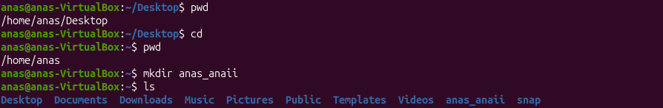
5: ll: list of files and directories are available.
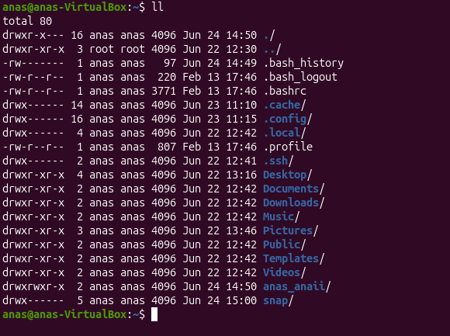

6: rm -rf: delete the directory.
7: touch: create file.
8: rm: delete the file.
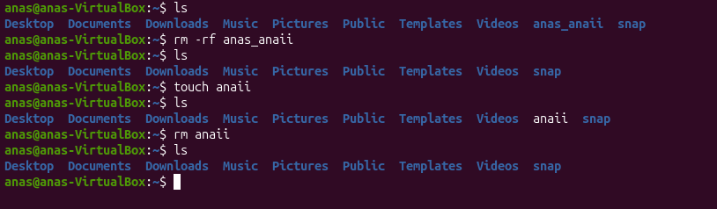
9: mv: editing the directory.
10: ls-a: show hidden files.
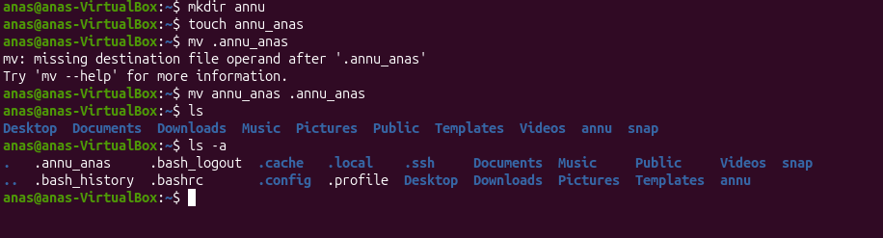

11: vi: create file and open editor.
12: cat: to read the content in the file.
13: wc: read the word count and to know how many lines available.
14: date: current date & time.
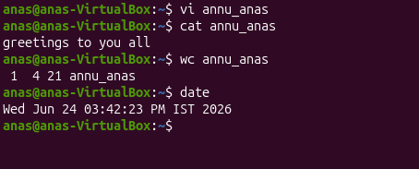
15: history: we can see all the commands which we used.
